SUBSCRIBERS GALORE: EXPLORING WORLD’S TOP YOUTUBE CHANNELS

# PROJECT REPORT

* OVERVIEW :  ***Subscribers galore : * Exploring the world’s top You tube channel is a concept that involves diving into the most popular and influential You tube channels across various genres * This would include content creators who have amassed a significant number of subscribers and have made a substantial impact on the platform . The exploration could cover channels from categories like gaming ,entertainment , education , music, lifestyle .***\****This project includes the categories like , list of channels,names, distribution of channels across the world and the number of subscribers***

PURPOSE ***: A subscriber to a channel on the video-sharing YouTube is a user who has chosen to receive the channel's content by clicking on that channel's "Subscribe" button, and each user's subscription feed consists of videos published by channels to which the user is subscribed. The ability to subscribe to users was introduced in October 2005. YouTube began publishing a list of its most- subscribed channels in April 2006. An early archive of the list dates to May 2006.***

***AVAILABILITY : The following table lists the 50 most-subscribed YouTube channels, as well as the primary language and content category of each channel. The channels are ordered by number of subscribers; those whose displayed subscriber counts are identical are listed so that the channel whose current growth rate indicates that its displayed subscriber count will exceed that of the other channel is listed first. .***

***EFFICIENCY : Automatically generated channels that lack their own videos (such as Music and News) and channels that have been made effectively obsolete as a result of the transferal of their content (such as Justin Bieber VEVO and Taylor Swift VEVO) are excluded. * SEVERAL OPTIONS: Automatically generated channels that lack their own videos (such as Music and News) and channels that have been made effectively obsolete as a result of the transferal of their content (such as Justin Bieber VEVO and Taylor Swift VEVO) are excluded..***

***SUBSCRIBER RANGE: As of February 2023, 21 of the 50 channels listed primarily produce content in English while 16 primarily produce content in Hindi. All 50 of the channels have surpassed 40 million subscribers, 39 of them have surpassed 50 million subscribers, 23 of them have surpassed 60 million subscribers, 16 of them have surpassed 70 million subscribers, 12 of them have surpassed 80 million subscribers, 10 of them have surpassed 90 million and 7 of them have surpassed 100 million subscribers. Only 1 channel (T-Series) has surpassed 200 million subscribers.***

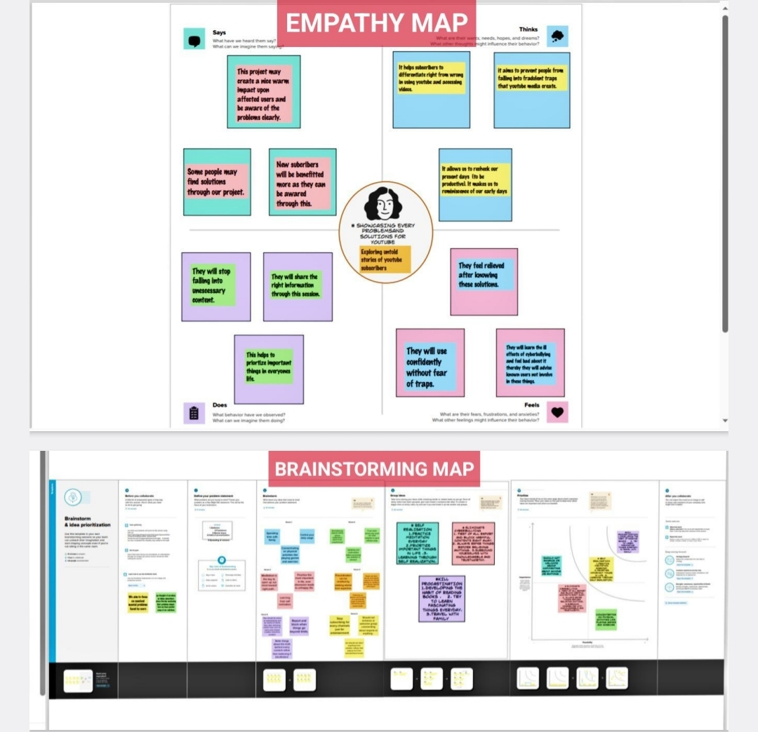

**PROBLEM DEFINTION AND DESIGN THINKING.**

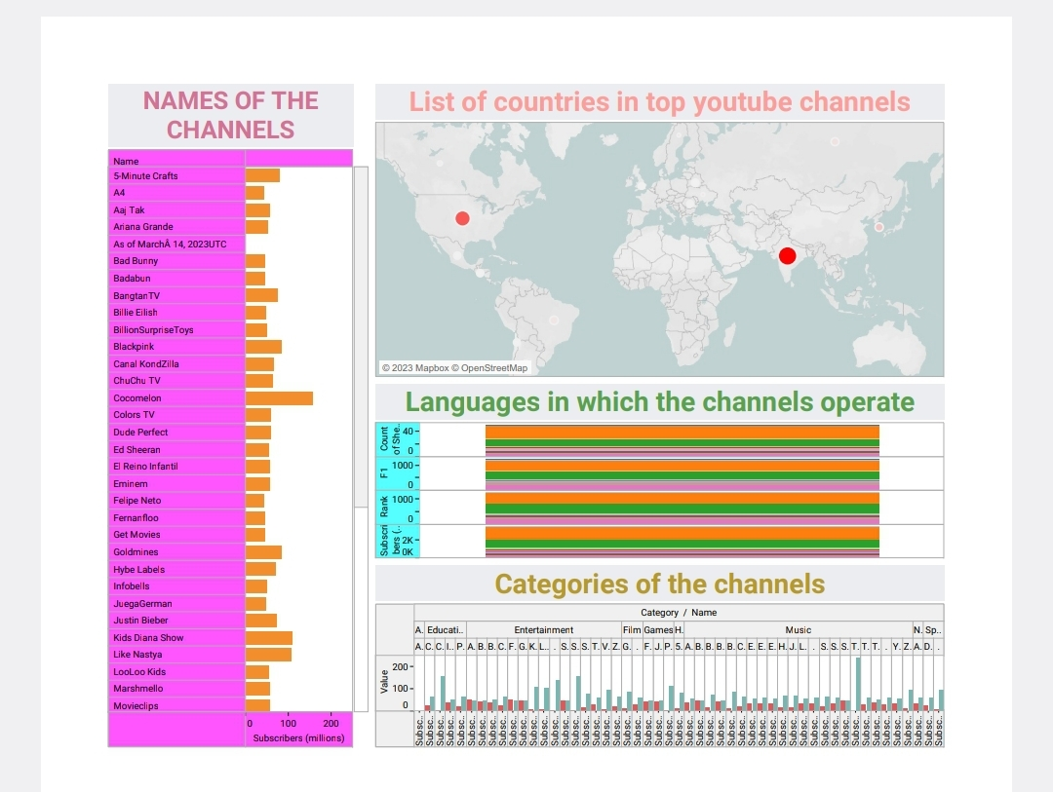

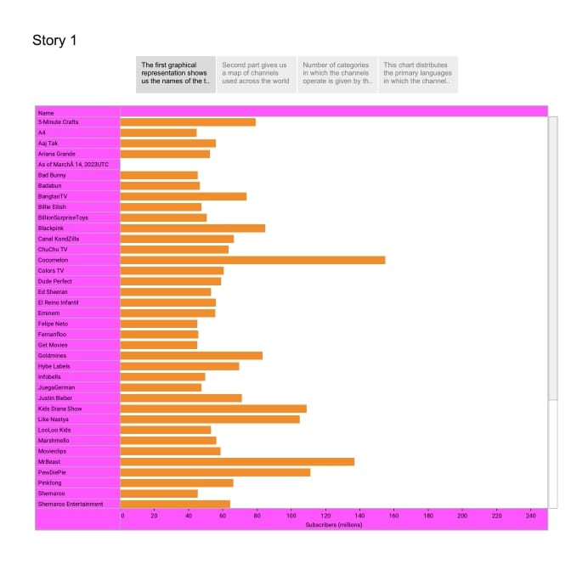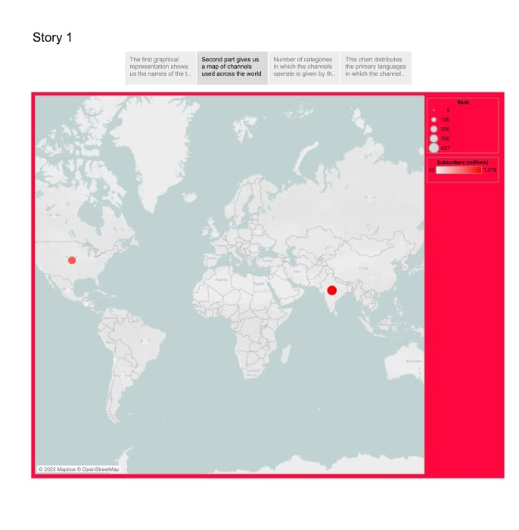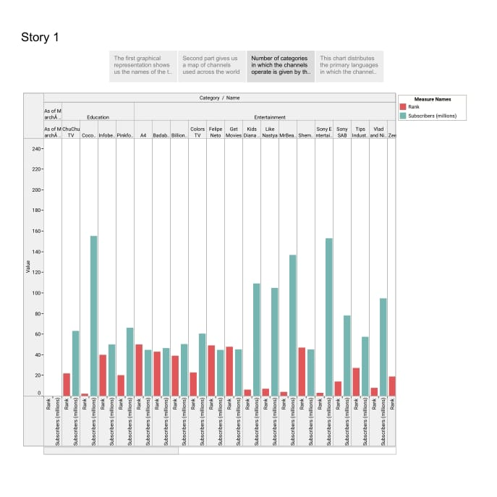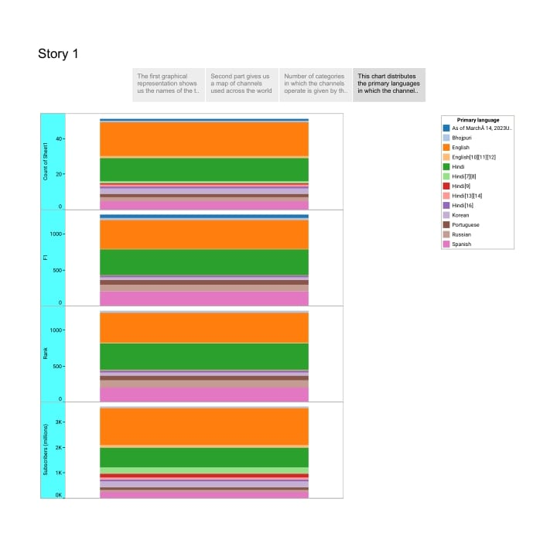

# ADVANTAGES AND DISADVANTAGES

# ADVANTAGES: 1. YouTube as an information disseminating platform for students : IT is the perfect place to learn and gain expertise . With online videos and ‘’how to do’’ tricks , gaining knowledge is simple . In the process, YouTube is now the second largest source of information after Google . According to most recent data, YouTube has around 2.3 billion active users as of 2021. There are many YouTube benefits for students in the automotive, IT engineering , financial and medical fields.

# 2. YouTube’s user– friendliness : If you are interested in food , religion , culture or parenting tips, there is a channel on YouTube that will offer online help. It is not just for professionals or pupils; YouTube is made for anyone to find what they enjoy , from pet lovers to homemakers, anyone can find content suitable to their interests. YouTube keep the content informative and stimulating.

# 3. Easy earning is at very top of the list of YouTube benefits for vloggers: Everyone is interested in the opportunities to turn the passion into a profit . This is exactly the kind of thing YouTube can offer any creator who has viewers. If your channels populated with viewers and interesting content , you will benefit the most from a YouTube channel. You can make money through your YouTube channel after it has reached the point of eligibility.

# DISADVANTAGES : 1. A lot of distractions. The platform is updated with new content each minute, making it difficult to avoid engaging and interesting videos. When you begin viewing YouTube videos, you will be able to continue watching more videos in the ‘’related videos’’ session. According to the research done by the collective , the issue of distraction while driving can be a worldwide problem that kills and injures thousands of every people each year. There are fatal outcomes of driving while being distracted by videos that depict a negative image of YouTube.

# 2. Ads – a drawback of youtube for the audience . There are some distinct disadvantages of watching YouTube videos. Which include a lot of commercial. It is possible to skip your mainstream. However, you are often required to watch commercial lasting between 15 and 20 seconds. This isn’t just time waster but it can be irritating at times. Another issue that associated with YouTube is that it requires you to pay a charge if you would like to view ads – free content.

# APPLICATIONS :

* **One of the biggest benefits of subscribing to a YouTube channel is being able to receive videos from the channel in your subscription box. The subscription box makes it easy for you to find new videos from channels you have subscribed to**
* **With YouTube Premium, you can watch millions of videos without interruptions by ads before and during a video, including video overlay ads. You will also not see third-party banner ads and search ads.**
* **Creators can now access the YPP once they reach 500 subscribers, which is half of what YouTube previously demanded. Also, instead of the previous requirement of 4,000 valid watch hours, creators now only need to achieve 3,000 watch hours**

**FUTURESCOPE**: **You can sign up for a YouTube affiliate or partner program to earn. However, to be eligible for these programs, you'll need to have at minimum 1000 subscribers as well as 4,000 watching hours over the last twelve months. If you're unable to achieve this, it will come with more drawbacks to YouTube than benefits.**

**While it's an easy and efficient method of earning money, it won't be as if it's growing on trees. YouTube has an algorithm that will scrutinize and validate every channel's legitimacy before allowing it to be played. Therefore, if you decide to play in a way that is not legitimate, YouTube has the algorithm to catch such activities too.**

**CONCLUSION**:

**There are many positive aspects to keep in mind about YouTube in comparison to the negatives. By analyzing the positives and negatives of YouTube, it is possible to get an idea of the number of users who receive the information and what percentage of them are misleading. The whole thing is based on people's interests, which is the reason YouTube exists, and so do YouTube channels.**